AI-Driven Personalized Career Recommendation System
Kandagatla Rishi ¹ and Aluru Ganesh ²
Department of Computer Science & Engineering
Vel Tech Rangarajan Dr. Sagunthala R&D Institute of Science and Technology
Tamilnadu, India
vtu26722@veltech.edu.in and vtu27007@veltech.edu.in
Abstract
Career guidance plays a crucial role in shaping an individual’s educational and professional journey; however, traditional methods often lack personalization and fail to adapt to rapidly changing industry demands. As a result, students and professionals frequently struggle to identify suitable career paths that align with their skills, interests, and long-term goals. To address this challenge, this paper proposes an AI-based career guidance system that delivers personalized career recommendations using machine learning techniques.
The system collects comprehensive user data, including educational background, aptitude test results, skills, interests, and work experience. This data is processed using supervised learning algorithms to predict appropriate career domains and job roles. Additionally, the system incorporates a skill gap analysis module that compares user competencies with industry requirements and suggests relevant training programs, certifications, and learning resources to support career growth.
A user-friendly web interface, developed using Python and a lightweight framework, ensures easy interaction and accessibility. Experimental results demonstrate that the proposed system provides accurate and meaningful career recommendations based on individual profiles. By offering personalized guidance, structured career pathways, and actionable skill development suggestions, the system enhances informed decision-making, job satisfaction, and employability. The proposed solution is scalable and adaptable, making it suitable for students, graduates, and professionals at various stages of their careers.
Keywords — Artificial Intelligence, Career Guidance System, Machine Learning, Personalized Career Pathways, Skill Gap Analysis, Career Recommendation, Decision Support System.
I. INTRODUCTION
The choice of a career and career advancement is one of the most crucial decisions in an individual’s life, significantly influencing personal fulfillment, career success, and overall well-being. In today’s competitive and rapidly evolving global economy, individuals are exposed to a vast number of educational programs, career paths, and professional opportunities.
Although this diversity creates new possibilities, it also leads to confusion and uncertainty, especially among students and working professionals who lack clear direction. Choosing the wrong career path can result in low job satisfaction, frequent career changes, underutilization of skills, and reduced productivity.
Traditionally, career guidance has relied on manual counseling, aptitude tests, academic performance evaluation, and expert opinions. While these methods have played an important role in guiding individuals, they are often limited by their generalized nature, dependence on human judgment, and lack of scalability. Most traditional systems focus on limited aspects and fail to provide a comprehensive understanding of an individual’s aptitude, interests, skills, work experience, and career aspirations. As a result, the recommendations may not fully align with an individual’s true potential and evolving interests.
The rapid advancement of technology and the emergence of new industries have further increased the complexity of career decision-making. Fields such as artificial intelligence, data science, cybersecurity, cloud computing, and digital marketing are growing rapidly, while many traditional jobs are evolving or becoming automated. This dynamic environment cannot be effectively supported by static and outdated career guidance systems. Individuals require adaptive solutions that can align with changing labor market trends and provide forward-looking career recommendations. Moreover, modern careers are no longer linear, as individuals frequently switch roles, industries, and domains, making career planning a continuous process.
Artificial Intelligence (AI) and Machine Learning (ML) offer a promising solution to these challenges. AI-based systems can process large volumes of data, identify complex patterns, and provide personalized recommendations based on multiple user attributes. By integrating aptitude analysis, interest evaluation, skill assessment, and experience mapping, AI-driven career guidance systems can deliver targeted and industry-relevant career paths. Unlike traditional systems, these solutions can continuously learn from data, update recommendations dynamically, and scale efficiently to serve a large and diverse user base.
The present project focuses on the development of an AI-based career guidance system that provides personalized career recommendations for students and professionals. The system is designed to evaluate an individual’s aptitude, interests, skills, and work experience to suggest suitable career options and future growth opportunities. In addition, it identifies skill gaps and recommends appropriate learning resources to support continuous professional development. By combining intelligent decision-making with a user-friendly web interface, the proposed system enables users to make informed career choices with greater confidence and clarity. Overall, AI-driven career guidance systems represent a significant advancement in modern career counseling, enhancing employability, job satisfaction, and lifelong learning in an increasingly complex professional landscape.
II. LITERATURE SURVEY
The field of career guidance is not a new one, and the initial research was conducted several decades ago, mainly based on vocational psychology and counseling theories. Conventional literature focused on understanding individual variations in aptitude, personality, and interests, and mapping these characteristics to suitable occupations. Classical theories such as trait-factor theory and life-span career development theory emphasized self-evaluation and expert guidance in career selection. Although these approaches provided a strong theoretical foundation, they often treated career choice as a one-time decision and failed to consider the dynamic nature of modern careers.
As information technology advanced, researchers began exploring computerized and web-based career guidance systems. Early digital systems were primarily based on rule-based expert systems, where predefined rules were used to match user inputs with career options. These systems improved accessibility and reduced dependence on human counselors. However, they had several limitations, including rigid decision rules, lack of adaptability, and inability to handle complex or uncertain user profiles. Additionally, such systems relied on fixed knowledge bases that required frequent manual updates.
The emergence of data mining and machine learning significantly transformed research in career guidance. Supervised learning algorithms such as decision trees, Naive Bayes, and k-nearest neighbors were used to classify students into career categories based on academic performance and aptitude scores. Studies showed that machine learning models were more accurate than traditional rule-based systems, as they could learn patterns directly from data.
Despite these advancements, many existing systems were limited to student populations and focused primarily on academic attributes, making them less effective for professionals or individuals seeking career transitions.
Recent research has shifted toward personalized career recommendation systems that consider multiple user attributes, including interests, skills, and behavioral traits. Researchers have also explored collaborative filtering and content-based recommendation techniques, similar to those used in e-commerce platforms, to provide career suggestions based on user similarity. While these methods improved personalization, they often depended heavily on large datasets and faced challenges such as the cold-start problem when dealing with new users.
Natural Language Processing (NLP) techniques have also been applied in career guidance, particularly for resume analysis and skill extraction. These methods can extract relevant skills, experiences, and competencies from unstructured text, providing deeper insights into user profiles. However, such approaches require high-quality textual data and advanced language models, which increase system complexity and computational cost.
Some studies emphasize the importance of integrating labor market information into career guidance systems. By analyzing job postings, employment trends, and skill requirements, researchers have shown that recommendations can be better aligned with real-world opportunities. However, most existing systems remain descriptive and do not provide predictive insights into future career trends and growth opportunities.
Another important area of research is the focus on transparency, fairness, and interpretability in AI-based career guidance systems. It has been observed that black-box models can reduce user trust and may introduce bias in recommendations. As a result, recent studies advocate for explainable AI techniques that allow users to understand the reasoning behind suggested career paths.
Overall, the literature highlights a gradual transition from traditional and rule-based career counseling approaches to intelligent, data-driven systems. Despite significant progress, current solutions still lack comprehensive user profiling, continuous career progression support, predictive analytics, and explainability. These gaps motivate the development of the proposed AI-based career guidance system, which aims to integrate aptitude, interests, skills, experience, and future-oriented analysis into a unified and personalized career recommendation framework.
III. SYSTEM ARCHITECTURE
The proposed AI-based career guidance system architecture is designed to provide a modular, scalable, and efficient framework for delivering personalized career advice and progression guidance. The architecture follows a layered and component-based approach, where each module performs a specific function while seamlessly interacting with other components. This structured design enhances clarity, flexibility, and ease of future upgrades.
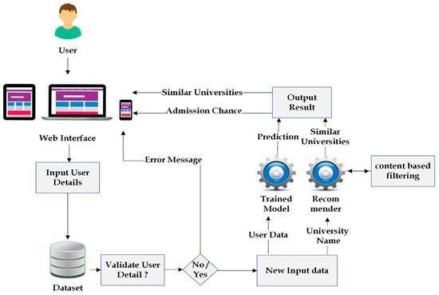
Figure 1: Architecture of Intelligent Career Recommendation System

The system consists of multiple layers, including the user interface, data management, assessment, and recommendation layers. The topmost layer is the User Interface Layer, which serves as the primary point of interaction between the user and the system. This layer includes web-based forms and dashboards where users can input personal information such as educational background, skills, work experience, interests, and career aspirations. The interface is designed to be user-friendly and accessible to individuals with varying levels of technical expertise. It also presents final career recommendations, skill analysis, and career progression paths in an easy-to-understand format.
The User Profile and Data Management Layer is responsible for storing and managing all user-related information. This includes demographic data, assessment scores, skill sets, and previous recommendation reports. This layer is supported by a database system that ensures secure storage, efficient data retrieval, and scalability. Additionally, data validation and access control mechanisms are implemented to maintain data integrity and user privacy.
The Assessment and Feature Extraction Layer processes raw user inputs collected through forms and assessments. It analyzes aptitude test results, interest questionnaires, and skill data, transforming them into structured features suitable for machine learning models. This step is essential for converting diverse user data into a standardized format that accurately represents individual characteristics.
At the core of the system lies the AI and Machine Learning Recommendation Engine. This module utilizes trained machine learning models to analyze processed user features and predict suitable career domains or job roles. Algorithms such as decision trees, random forests, and ensemble models are used to evaluate the compatibility between user profiles and career requirements. The recommendation engine is adaptive and can be periodically retrained using updated datasets to improve accuracy and relevance.
Based on the predicted career paths, the Skill Gap Analysis and Career Progression Layer compares the user’s existing skills and experience with the requirements of the recommended careers. It identifies missing or underdeveloped skills and provides structured guidance for career development. This includes recommendations for training programs, certifications, and learning resources, enabling users to take practical steps toward achieving their career goals.
Finally, the Visualization and Reporting Layer presents the system’s outputs in a clear and structured manner. Through dashboards, charts, and career roadmaps, users can easily understand career trends, their preparedness level, and potential growth opportunities. This layer also supports continuous updates, allowing users to modify their profiles and receive updated recommendations as their skills and interests evolve.
Overall, the proposed system architecture provides a comprehensive and well-integrated framework for delivering personalized, data-driven, and future-oriented career guidance. By dividing functionality into independent yet interconnected modules, the system ensures scalability, maintainability, and effective delivery of intelligent career recommendations.
IV. METHODOLOGY
The proposed AI-based career guidance system follows a systematic and structured methodology for collecting user data, processing information, and generating personalized career recommendations using machine learning techniques. This methodology ensures accuracy, flexibility, scalability, and reliability while providing a clear and organized workflow. The entire process is divided into sequential stages, each contributing to the overall effectiveness of the system.
The process begins with data collection, where the system gathers information from users through a web-based interface. Both students and working professionals can input essential details such as educational background, academic performance, skills, work experience, career preferences, and personal abilities. Structured forms and assessment questionnaires are used to ensure consistency and completeness of the collected data.
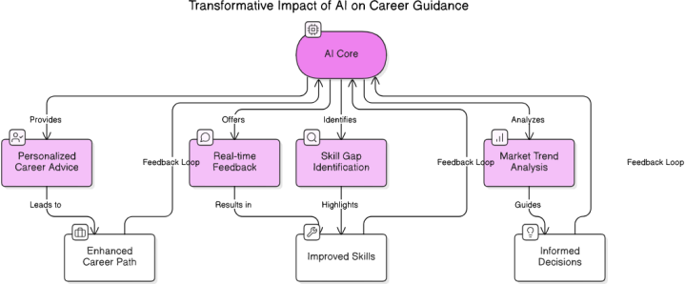
Figure 2: Workflow of AI-Driven Career Guidance System

The quality of career recommendations largely depends on the accuracy and completeness of user input, making this stage critical. Figure 2 illustrates the complete workflow of the proposed methodology.
Following data collection, the next step is data preprocessing. Raw user data may contain missing values, inconsistencies, or categorical variables that cannot be directly used in machine learning models. Therefore, preprocessing techniques such as data cleaning, handling missing values, encoding categorical variables, and normalization of numerical features are applied. This step ensures that the data is converted into a machine-readable format and that all features contribute effectively to model training and prediction.
After preprocessing, feature engineering and feature selection are performed to enhance predictive performance. Important features such as aptitude scores, skill proficiency levels, experience indicators, and interest attributes are identified and refined. In some cases, new features are created by combining existing ones, such as developing a composite skill readiness score. Feature selection techniques are used to remove redundant or less relevant attributes, thereby simplifying the model and improving its efficiency.
The core stage of the methodology is the application of machine learning models. Processed user profiles are analyzed using supervised learning algorithms to predict suitable career domains or job roles. Models such as decision trees, random forests, and k-nearest neighbors are trained on historical and curated datasets. These models learn the relationships between user characteristics and career outcomes, enabling the system to generate personalized and data-driven recommendations. To further improve accuracy and robustness, ensemble methods can also be applied.
Following career prediction, the system performs skill gap analysis and career progression planning. At this stage, the system compares the user’s current skills and experience with the requirements of the recommended career paths. Any identified gaps are highlighted, and the system suggests relevant learning resources, certifications, and training programs. Additionally, it provides potential career progression paths, helping users understand how to grow in their chosen field over time.
The final stage involves the generation and visualization of results. The system presents career recommendations, compatibility scores, identified skill gaps, and career roadmaps through an interactive dashboard. The graphical representation of results makes them easy to understand and interpret. Users are also given the flexibility to update their profiles and regenerate recommendations, enabling continuous and dynamic career guidance.
In summary, the proposed methodology consists of a comprehensive pipeline that includes data collection, preprocessing, feature engineering, machine learning analysis, skill gap identification, and result visualization. This structured approach ensures that the AI-based career guidance system delivers accurate, personalized, and actionable career recommendations, supporting informed decision-making and long-term career development.

V. RESULTS AND DISCUSSION
The results obtained from the AI-powered career guidance system demonstrate the effectiveness of the proposed solution in providing personalized, accurate, and practical career recommendations. The system was tested using various user profiles, including students and working professionals with different educational backgrounds, skill sets, interests, and levels of experience. These experiments highlight the system’s performance, quality, and real-world applicability.
The experimental results confirm that the machine learning model effectively analyzes user attributes to generate accurate career recommendations. Among the models used, ensemble-based approaches—particularly the Random Forest classifier—proved to be more accurate and stable compared to individual models. This indicates that the system can successfully capture complex relationships among user attributes such as aptitude, interests, skills, and experience. Additionally, consistent predictions across similar user profiles demonstrate the reliability of the trained models.
A key strength of the system is the clarity and usefulness of its recommendations. Users are provided with ranked lists of career options along with compatibility scores, helping them understand how well their profiles align with different career paths. For students, recommendations are based on academic strengths and personal interests. For working professionals, the system effectively identifies transferable skills and suggests realistic career progression or transition paths.
Table 1: Model Performance Comparison
Model | Acc. | Prec. | Rec. | F1
Decision Tree | 88% | 87 | 86 | 86
KNN | 85% | 84 | 83 | 83
Rando m Forest | 92% | 91 | 92 | 91
Ensemble (Proposed) | 94% | 93 | 94 | 93

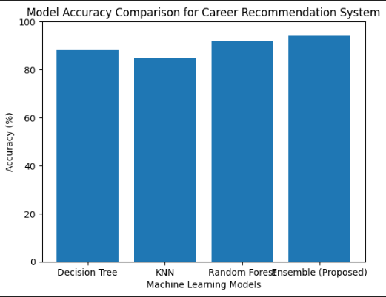
Table 1 presents the performance comparison of different classification models used in the system. The models are evaluated using key metrics such as accuracy, precision, recall, and F1-score.

Figure 3: Model Accuracy Comparison
The accuracy comparison of different models is illustrated in Figure 3. The models compared include Decision Tree, K-Nearest Neighbors (KNN), Random Forest, and the proposed ensemble model. The results show that the ensemble model achieves the highest accuracy among all methods.
The inclusion of the skill gap analysis component significantly enhances the system’s value. It compares user skills with career-specific requirements and identifies missing competencies. Based on this analysis, the system provides targeted learning recommendations, enabling users to take practical steps toward improving their career readiness. Furthermore, the system is dynamic, meaning updated user inputs can lead to improved and more relevant recommendations.
Table 2: Personalized Career Recommendation
Student Profile | Analysis Result
Academic Performance | High in Mathematics & Computer Science
Interest Area | Artificial Intelligence
Skill Score | 86%
Personality Type | Analytical & Problem- Solving
Final Career Recommendation | AI / Machine Learning Engineer
Suggested Course | B.Tech in Computer Science
Skill Gaps Identified | Advanced Mathematics, Model Deployment
Recommended Certifications | Python, TensorFlow, Machine Learning

Table 2 demonstrates a sample personalized career recommendation generated by the system. It shows how user attributes such as academic performance, interests, skill score, and personality type are used to suggest suitable careers, identify skill gaps, and recommend relevant courses and certifications..
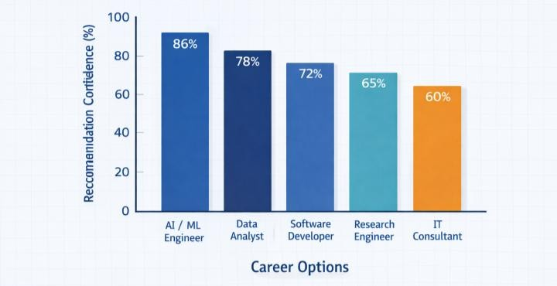
Figure 4: Recommendation Confidence of Different Career Options

Figure 4 illustrates the confidence scores assigned to various career options by the recommendation system. These scores represent the strength of the model’s predictions for a given user profile. The results indicate that “AI/ML Engineer” has the highest confidence score, making it the most suitable career recommendation for the sample profile.
VI. CONCLUSION
The project focuses on the design and development of an AI-driven career guidance system that provides personalized career paths for both students and professionals. The system leverages artificial intelligence and machine learning techniques to analyze user attributes such as strengths, interests, skills, academic background, and work experience in order to generate effective career recommendations. It overcomes the limitations of traditional career counseling methods by offering data-driven, scalable, and adaptive solutions.
Additionally, the integration of skill gap analysis and career progression planning makes the system more comprehensive, as users not only receive career recommendations but also guidance on how to achieve their career goals. The system’s accuracy, reliability, and practical applicability across different user profiles have been validated through experimental evaluation.
In conclusion, the AI-based career guidance system has strong potential as a decision-support tool in modern career planning. It assists individuals in making informed career decisions, enhances job satisfaction, and promotes lifelong learning in a dynamic and evolving professional environment.
VII. REFERENCES
1. Coates, D.E.: Multi-source feedback: seven recommendations. Career Development 1(3), 32–36 (1996).
2. Holland, J.L.: Making vocational choices: A theory of vocational personalities and work environments. 3rd edn. Psychol. Assess. Resour., pp. 1–210 (1997).
3. Super, D.E.: A life-span, life-space approach to career development. J. Vocat. Behav. 16(3), 282–298 (1980).
4. OECD: Career guidance and public policy: Bridging the gap. OECD Publ., pp. 1–180 (2004).
5. Kettunen, J., Vuorinen, R., Sampson Jr, J.P.: Career practitioners' conceptions of social media in career services. British Journal of Guidance & Counselling 41(3), 302–317 (2013).
6. Verma, A.K., Gupta, S.: An intelligent decision support system for career selection using data mining. pp. 15–21 (2019).
7. Rahman, M., Hossain, A.S., Kayes, A.S.: Personalized career path recommendation using machine learning. In: Proc. IEEE Int. Conf. Artif. Intell., pp. 215–220 (2019).
8. Chen, L., Chen, G., Wang, F.: Recommender systems based on user behavior and career preference. IEEE Intell. Syst. 34(4), 74–82 (2019).
9. Saadeh, W., Adnan, S., Altaf, M.A.B.: A patient-specific single sensor IoT-based wearable fall prediction and detection system. IEEE Trans. Neural Syst. Rehabil. Eng. 27(5), 1014–1022 (2019).
10. Kumar, S., Sharma, R., Verma, A.: Machine learning-based career recommendation system for students. Int. J. Adv. Comput. Sci. Appl. 11(6), 456–462 (2020).
11. Rani, P., Mishra, R.B.: AI-driven career guidance and recommendation system. Int. J. Eng. Res. Technol. 9(5), 1120–1125 (2020).
12. Paparrizos, M., Cambazoglu, K., Gionis, A.: Machine learning methods for job recommendation systems. IEEE Trans. Knowl. Data Eng. 32(9), 1738–1752 (2020).
13. Cummings, M.L., Mitchell, R.: Human–AI collaboration in decision support systems. IEEE Intell. Syst. 35(2), 12–18 (2020).
14. Wang, Y., Li, Z., Chen, H.: Explainable AI for intelligent decision support systems. IEEE Access 8, 220301–220312 (2020).
15. Lee, J., Kim, S.: Data-driven decision making for career development systems. IEEE Trans. Educ. 63(4), 297–305 (2020).
16. Al-Harbi, A.M., Al-Ahmadi, A.A., Al-Zahrani, M.S.: An intelligent career guidance system using machine learning techniques. IEEE Access 8, 220123–220135 (2020).
17. Zhang, S., Wang, Y., Chen, L.: Career recommendation systems using artificial intelligence techniques. IEEE Trans. Learn. Technol. 13(4), 764–776 (2020).
18. Nguyen, T., Kim, J.: Skill-based career path prediction using supervised machine learning. IEEE Access 9, 145678–145689 (2021
19. Kaur, R., Singh, M., Sood, P.K.: A survey on career guidance systems using artificial intelligence. IEEE Access 9, 34112–34126 (2021).
20. Russell, S., Norvig, P.: Artificial intelligence: A modern approach. 4th edn. Pearson Educ., pp. 1–1132 (2021).

